**CRUD**

**1 . TECHNOLOGIES**

HTML,CSS, BOOTSTRAP, PHP 7, JUQERY, AJAX, MYSQL.

**2. DESCRIPTIONS:**

A user want can create/register simple account basic information’s enhanced the unique email ID, forma validations, session concept. If you don’t want account you can delete your own credentials. Here attached all php files along sql.

**3. STEPS:-**

<http://localhost/userRegister/>

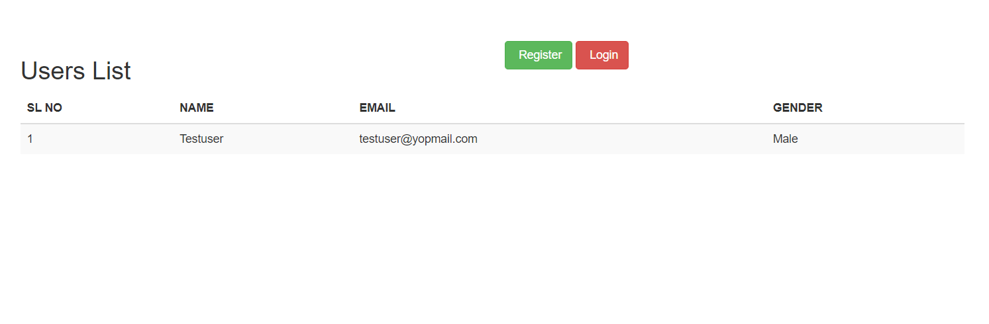

**Register:**

<http://localhost/userRegister/userRegister.php>

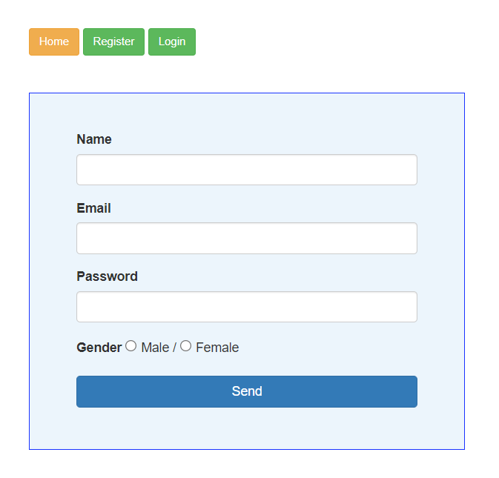

**Login:-**

Once user create account able to login here using the menu tab methods

same link:- <http://localhost/userRegister/userRegister.php>

**Email:- testuser@yopmail.com**

**Pswd:- test123**

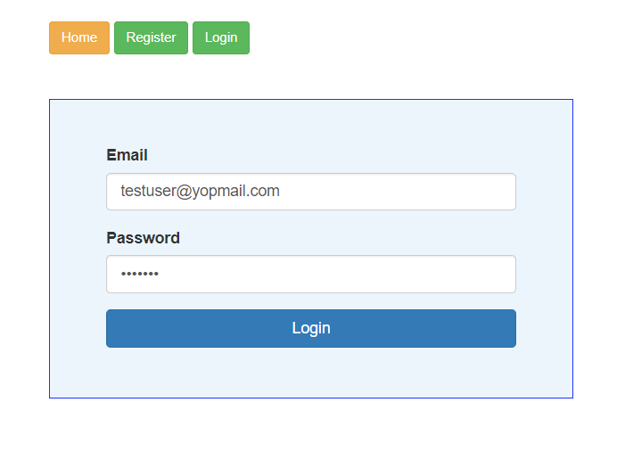

User can view here details and able change information’s ,

<http://localhost/userRegister/userEditRegister.php>